MAS9 Installation Guide (JumpBox Setup) :
***Using personal laptop to save cloud costing***
Same steps can be followed on cloud VM(JumpBox) for setup (Using RHEL OS)
- Install OpenShift CLI (To connect OpenShift cluster and perform operations)
Step 1 : Download OpenShift CLI on your Linux machine
https://access.redhat.com/downloads/content/680/ver=4.21/rhel---9/4.21.3/aarch64/product-software
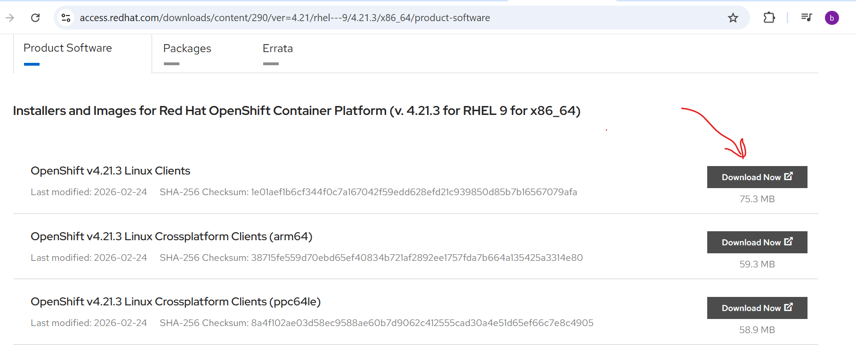
Step 2 : Go to VM’s Terminal
Check in downloads and create one new folder oc (or you can create with any name) to extract tar file.
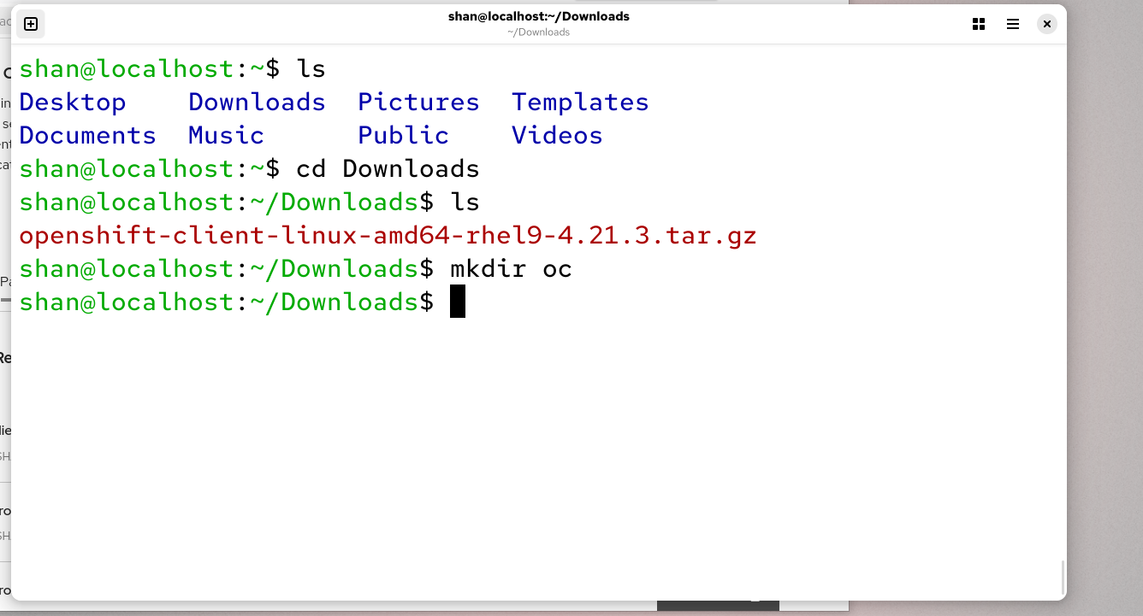

Step 3 : Run the following commands to extract tar file and install openshift CLI
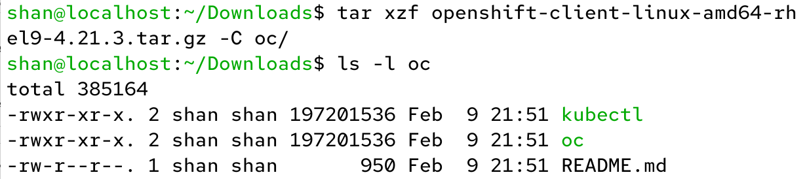
Move oc and kubectl to your system path to run oc command from anywhere.
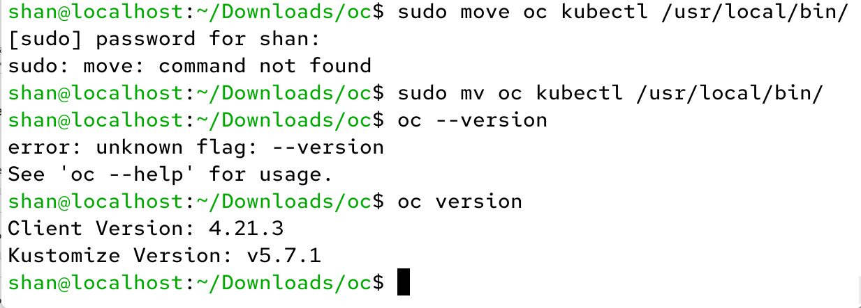
***OC CLI Installation completed if you can see the Client Version.***
- Install Required Packages
- Run this command to install required packages in installation.
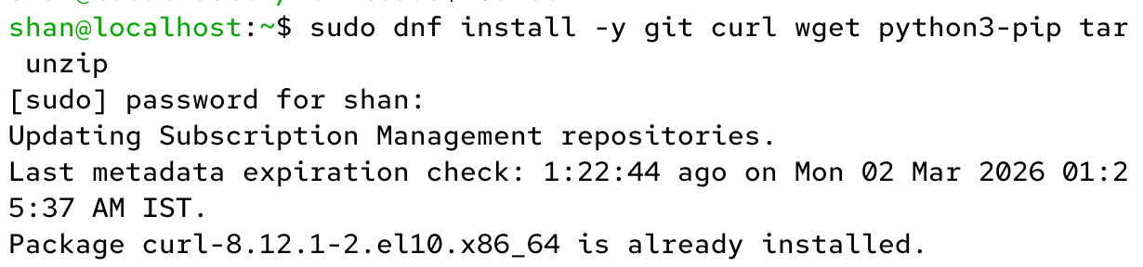

- Install Azure CLI
- Import the Microsoft repository key: Import the GPG key to ensure package integrity.
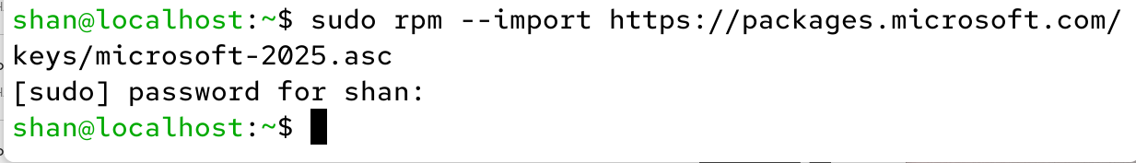

- Add the Azure CLI repository
***In this command give your rhel os version
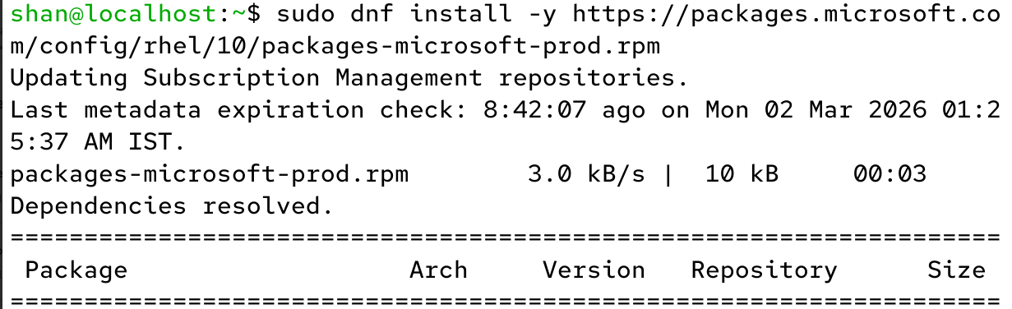

- Install Azure CLI
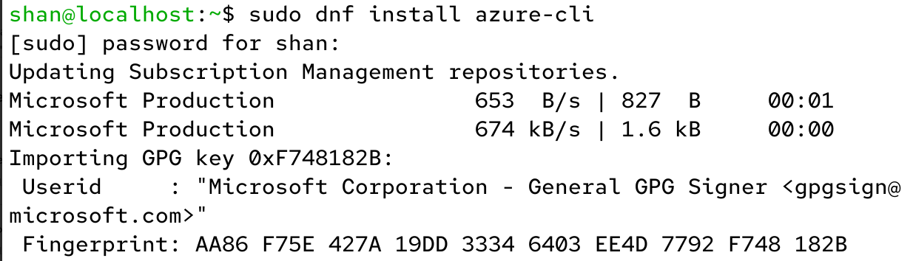

- Verify Azure CLI installation
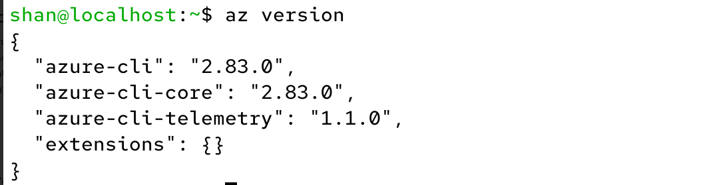

- Install Ansible
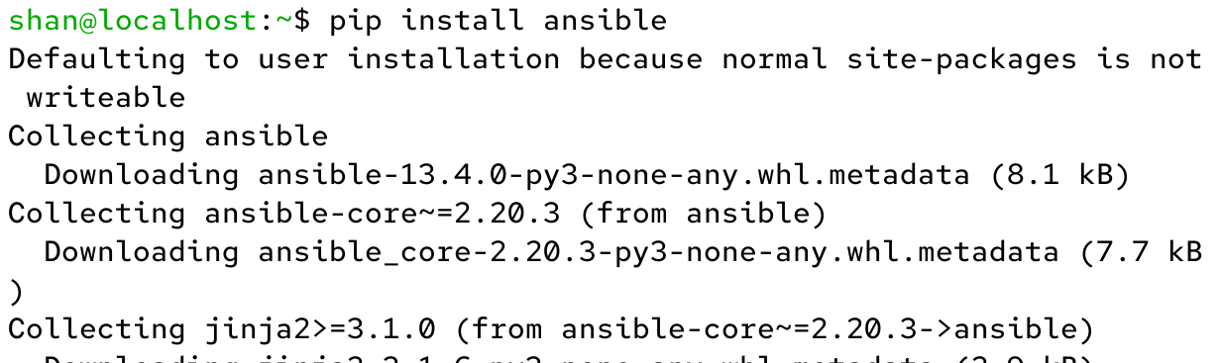

- Install MAS Ansible Collection
